**Sky High Carbon**

**An Insight into Europe's Airplane Emissions**

Carolina Chassi, Justin Liao, Kevin Ohgami, Roshan Peri

1. *Introduction*

Climate change represents one of the most significant challenges of our time, with carbon dioxide (CO2) emissions being a major contributor. Reducing our carbon footprint is essential for a sustainable future. This article emphasizes the critical role of data science in analyzing CO2 emissions in Europe, utilizing extensive datasets to inform policy decisions and promote further research.

This study focuses on the monthly and yearly CO2 emissions of several European countries, specifically Albania and Bosnia and Herzegovina. By employing data science methodologies, we aim to identify trends and seasonal variations in emissions, enhancing our understanding of each country's contribution to climate change. This analysis supports the ambitious targets for reducing greenhouse gas emissions set forth by the European Union and global agreements such as the 2015 Paris Agreement.

*Data Source*

The Data used for this article has clear documentation.[2] The dataset is in CSV format and encompasses crucial information including year, month, country name, country code, CO2 quantity measured in tons, and traffic volume for each state. This study focused on data collected from 2020 to 2023.

The data used was supplied by the EUROCONTROL Aviation Sustainability Unit.[1] CO2 emissions were measured using the EUROCONTROL Small Emitters Tool (SET). In this case, we used data were SET estimated the fuel burned and the associated CO2 emissions of an entire flight with known aircraft type and actual flown distance (full trajectory from origin to destination). Each countries’ CO2 emissions were calculated based on the departing IFR flights billed by the EUROCONTROL Route Charges Office.* For reference, the CO2 emissions for a flight from Athens to Madrid would be a part of the results for Greece and not for Spain.

For this study, a preprocessing approach was applied to the annual CO2 emission data sourced from multiple countries. The process involved reading a CSV file line by line, extracting country names and corresponding emission values, and normalizing country identifiers to ensure consistency across datasets. Importantly, integrity was maintained by filtering out countries with incomplete annual emission records, ensuring that only those with complete datasets representing all twelve months were retained for further analysis. By doing so, the data became suitable for various statistical computations and numerical analyses, which are essential for gaining insights into annual emission trends across diverse nations. This approach not only ensured data accuracy but also facilitated a clearer understanding of how emissions varied over time and across different geographical regions.

1. *Code Functionality*

The Python script developed is designed to analyze and visualize CO2 emission data across different time scales for multiple countries. The core functions of the script are the following:

read_file_yearly(filename): This function reads a CSV file of CO2 emissions, organizes the data into a dictionary (year_emission), and filters out countries with incomplete data (less than 12 months). Each key in the dictionary represents a country, and the corresponding value is a list of monthly emissions.

visual_yearly(year): Utilizes data from read_file_yearly to compute and display the average yearly CO2 emissions per country using Matplotlib. It generates a bar chart with countries on the x-axis and emission averages (in pounds) on the y-axis.

visual_monthly(combined_df, country): Visualizes monthly CO2 emissions for a specified country. It uses combined data from multiple years to plot a line chart, showing emissions per month for each year in different colors.

visual_heatmap(combined_df, country): Creates a heatmap to visualize monthly CO2 emissions over multiple years. The heatmap provides a comprehensive view of how emissions vary across months and years, highlighting seasonal and annual trends.

1. *Yearly Analysis*

To understand the global impact of CO2 emissions, we visualized the yearly average CO2 emissions by country from 2020 to 2023.

Fig 1 Yearly Average of CO2 Emission per Country in Dataset (2020)¶

The plots for every year from 2020 to 2023 is shown in the appendix.

Each line in Fig. 1 represents a different country, showcasing the trends in CO2 emissions over the years. Our analysis reveals that countries like Belgium, Germany, and France consistently show higher levels of CO2 emissions compared to other nations, reflecting their large industrial bases and energy consumption patterns. Conversely, smaller countries such as Albania, Bosnia and Herzegovina, and Luxembourg show significantly lower emissions, indicating their smaller industrial activities and or possibly more efficient energy use and reliance on renewable sources. Over the analyzed period, we observe a noticeable stability in emissions for most countries, with slight fluctuations that could be attributed to seasonal economic activities or policy changes.

1. *Monthly Analysis*

Focusing on the monthly CO2 emissions, we selected Albania and Bosnia and Herzegovina for a more detailed analysis due to their relatively low emission levels.

Fig. 2 Monthly CO2 Emissions for Albania (2020-2023) ¶

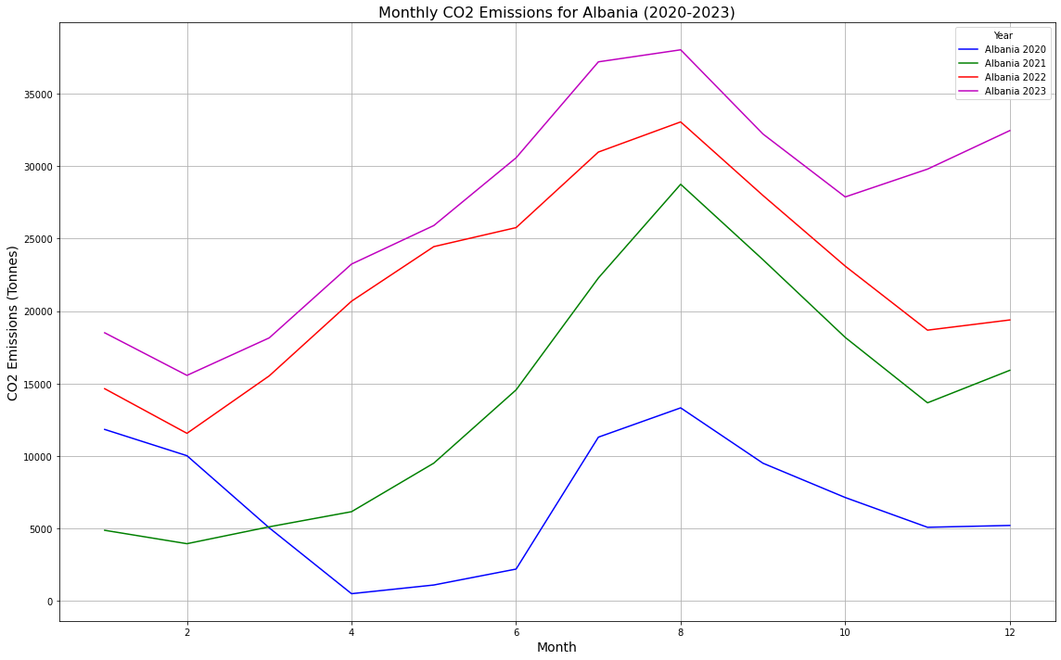

In Albania, we see clear seasonal patterns in CO2 emissions. There is a noticeable increase in emissions during the winter months (around January to March), likely due to higher energy consumption for heating. Emissions tend to be lower during the summer months (June to August), probably because of reduced heating requirements and possibly increased use of renewable energy sources during this period. Each year shows a general pattern of increasing emissions from the beginning of the year, peaking around September or October, and then decreasing towards the end of the year.

Fig. 3 Monthly CO2 Emissions for Bosnia and Herzegovina (2020-2023) ¶

In Bosnia and Herzegovina, the seasonal trends are similar, although with different magnitudes. Emissions rise significantly during the winter months and decrease in the summer, similar to Albania. However, the overall emission levels are lower compared to Albania, which could be attributed to differences in industrial activities and energy policies.

Fig. 4 CO2 Emissions Heatmap for Albania (2020 - 2023)

To further understand these trends, we used a heatmap to visualize the monthly CO2 emissions from 2020 to 2023. The heatmap for Albania (Fig. 4) clearly shows these seasonal variations, with darker shades indicating higher emissions during the winter months and lighter shades during the summer. The heatmap was essential to identify subtle patterns and variations in emissions across different months, providing a comprehensive view that line graphs alone couldn't offer.

Fig. 5 CO2 Emissions Heatmap for Bosnia and Herzegovina (2020 - 2023)

A graph of the temperature of the temperature of the temperature of the temperature of the temperature of the temperature of the temperature of the temperature of the temperature of the temperature of the temperature of the temperature of

The heatmap for Bosnia and Herzegovina (Fig. 5) also highlights these seasonal trends, with distinct peaks in emissions during the colder months and troughs during the warmer months. The heatmap provided a clear visual representation of these trends, making it easier to compare seasonal patterns year over year.

1. *Conclusion*

During our analysis, we faced challenges such as missing data and anomalies. We addressed these issues by interpolating the missing months and validating unusual spikes or drops. Despite these difficulties, we gained valuable insights, such as the clear seasonal CO2 emission patterns and generally lower emissions in Albania and Bosnia and Herzegovina. These findings underscore the influence of seasonal changes, economic activities, and policies on CO2 emissions.

The COVID-19 pandemic significantly impacted CO2 emissions in 2020, leading to a noticeable decrease in air traffic and emissions due to lockdowns and travel restrictions. This unprecedented event highlighted the strong link between human activity and environmental impact.

Future studies could leverage advanced techniques like machine learning to predict emissions and evaluate new environmental policies. By incorporating socio-economic data, we could enhance our understanding of the factors driving CO2 emissions, such as economic activities and population growth. Improved data collection methods and higher-quality data will further refine our analyses and predictions, aiding in effective policy-making.

In summary, our CO2 emissions analysis reveals significant insights into both global and country-specific patterns. Identifying seasonal trends and annual changes emphasizes the need for continuous monitoring and analysis. Utilizing data science is crucial for addressing climate change. Regular CO2 emissions analysis can help develop effective policies and promote sustainable practices. Recognizing the vital role of data science in combating climate change and supporting data-driven initiatives for sustainable development is essential. Through informed decisions and collective efforts, we can mitigate the impacts of climate change and secure a sustainable future.

1. *References*

[1] "EUROCONTROL Aviation Sustainability Unit. 'CO2 Emissions Dataset.' ansperformance.eu, <https://ansperformance.eu/csv/>.

[2] "EUROCONTROL Aviation Sustainability Unit. 'Reference Dataset: Emissions.' ansperformance.eu, <https://ansperformance.eu/reference/dataset/emissions/>.

**Appendix**

Appx. 1 Code

<Add finished code here>

Appx. 2 Plots

Plt. 1 Yearly Average of CO2 Emission (2020)

Plt. 2 Yearly Average of CO2 Emission (2021)

Plt. 3 Yearly Average of CO2 Emission (2022)

Plt. 4 Yearly Average of CO2 Emission (2023)

Plt. 5 Monthly CO2 Emissions for Albania (2020 - 2023)



Plt. 6 Monthly CO2 Emissions for Bosnia and Herzegovina (2020 - 2023)

Plt. 7 CO2 Emissions Heatmap for Albania (2020 - 2023)

Plt. 8 CO2 Emissions Heatmap for Bosnia and Herzegovina (2020 - 2023)

A graph of the temperature of the temperature of the temperature of the temperature of the temperature of the temperature of the temperature of the temperature of the temperature of the temperature of the temperature of the temperature of
